Blockchain Engineering
Name: Aman Sarkar
Ht.no: 2303A51273
Batch: 05
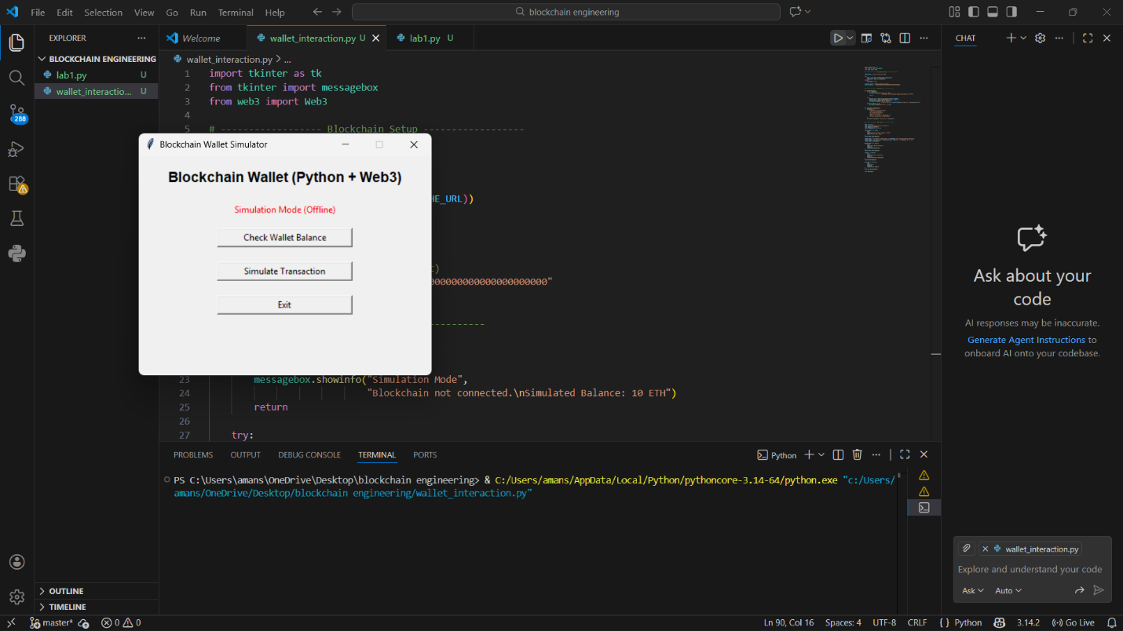

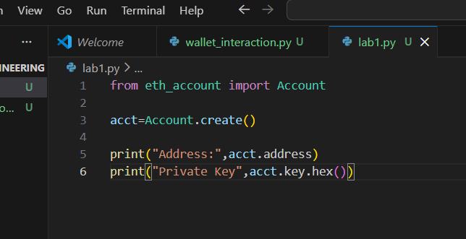

Address: 0x1EF6De9DC23D63f524706EABeEc502B36402b95a
Private Key: 6ba10d5d789b10b1dda16d0950427c56f632e8f32545eca019e58429785d8e54